**MIcroservices**

**AccountApplication.java**

package com.cognizant.account;

import org.springframework.boot.SpringApplication;

import org.springframework.boot.autoconfigure.SpringBootApplication;

import org.springframework.cloud.client.discovery.EnableDiscoveryClient;

@SpringBootApplication

@EnableDiscoveryClient

public class AccountApplication {

public static void main(String[] args) {

SpringApplication.*run*(AccountApplication.class, args);

}

}

**AccountController.java**

package com.cognizant.account.controller;

import org.springframework.web.bind.annotation.*;

@RestController

@RequestMapping("/accounts")

public class AccountController {

@GetMapping("/{number}")

public Account getAccount(@PathVariable String number) {

return new Account(number, "savings", 234343);

}

static class Account {

public String number;

public String type;

public double balance;

public Account(String number, String type, double balance) {

this.number = number;

this.type = type;

this.balance = balance;

}

}

}

**Application properties:**

server.port=8080

spring.application.name=account

eureka.client.service-url.defaultZone=http://localhost:8761/eureka

<?xml version="1.0" encoding="UTF-8"?>

<project xmlns="http://maven.apache.org/POM/4.0.0"

xmlns:xsi="http://www.w3.org/2001/XMLSchema-instance"

xsi:schemaLocation="http://maven.apache.org/POM/4.0.0

http://maven.apache.org/xsd/maven-4.0.0.xsd">

<modelVersion>4.0.0</modelVersion>

<groupId>com.cognizant</groupId>

<artifactId>account</artifactId>

<version>0.0.1-SNAPSHOT</version>

<name>account-service</name>

<description>Account Microservice</description>

<packaging>jar</packaging>

<parent>

<groupId>org.springframework.boot</groupId>

<artifactId>spring-boot-starter-parent</artifactId>

<version>2.6.3</version>

<relativePath/>

</parent>

<properties>

<java.version>11</java.version>

<spring-cloud.version>2021.0.7</spring-cloud.version>

</properties>

<dependencies>

<dependency>

<groupId>org.springframework.boot</groupId>

<artifactId>spring-boot-starter-web</artifactId>

</dependency>,m

<dependency>

<groupId>org.springframework.cloud</groupId>

<artifactId>spring-cloud-starter-netflix-eureka-client</artifactId>

</dependency>

<dependency>

<groupId>org.springframework.boot</groupId>

<artifactId>spring-boot-devtools</artifactId>

<scope>runtime</scope>

<optional>true</optional>

</dependency>

<dependency>

<groupId>org.springframework.boot</groupId>

<artifactId>spring-boot-starter-test</artifactId>

<scope>test</scope>

</dependency>

</dependencies>

<dependencyManagement>

<dependencies>

<dependency>

<groupId>org.springframework.cloud</groupId>

<artifactId>spring-cloud-dependencies</artifactId>

<version>${spring-cloud.version}</version>

<type>pom</type>

<scope>import</scope>

</dependency>

</dependencies>

</dependencyManagement>

<build>

<plugins>

<plugin>

<groupId>org.springframework.boot</groupId>

<artifactId>spring-boot-maven-plugin</artifactId>

</plugin>

</plugins>

</build>

</project>

**LoanApplication.java:**

**package** com.cognizant.loan;

**import** org.springframework.boot.SpringApplication;

**import** org.springframework.boot.autoconfigure.SpringBootApplication;

**import** org.springframework.cloud.client.discovery.EnableDiscoveryClient;

@SpringBootApplication

@EnableDiscoveryClient

**public** **class** LoanApplication {

**public** **static** **void** main(String[] args) {

SpringApplication.*run*(LoanApplication.**class**, args);

}

}

**Application.properties:**

server.port=8081

spring.application.name=loan

eureka.client.service-url.defaultZone=http://localhost:8761/eureka

EUREKA SERVER:

package com.cognizant.eureka_discovery_server;

import org.springframework.boot.SpringApplication;

import org.springframework.boot.autoconfigure.SpringBootApplication;

import org.springframework.cloud.netflix.eureka.server.EnableEurekaServer;

@SpringBootApplication

@EnableEurekaServer

public class EurekaDiscoveryServerApplication {

public static void main(String[] args) {

SpringApplication.*run*(EurekaDiscoveryServerApplication.class, args);

}

}

**Application.properties:**

server.port=8761

eureka.client.register-with-eureka=false

eureka.client.fetch-registry=false

logging.level.com.netflix.eureka=OFF

logging.level.com.netflix.discovery=OFF

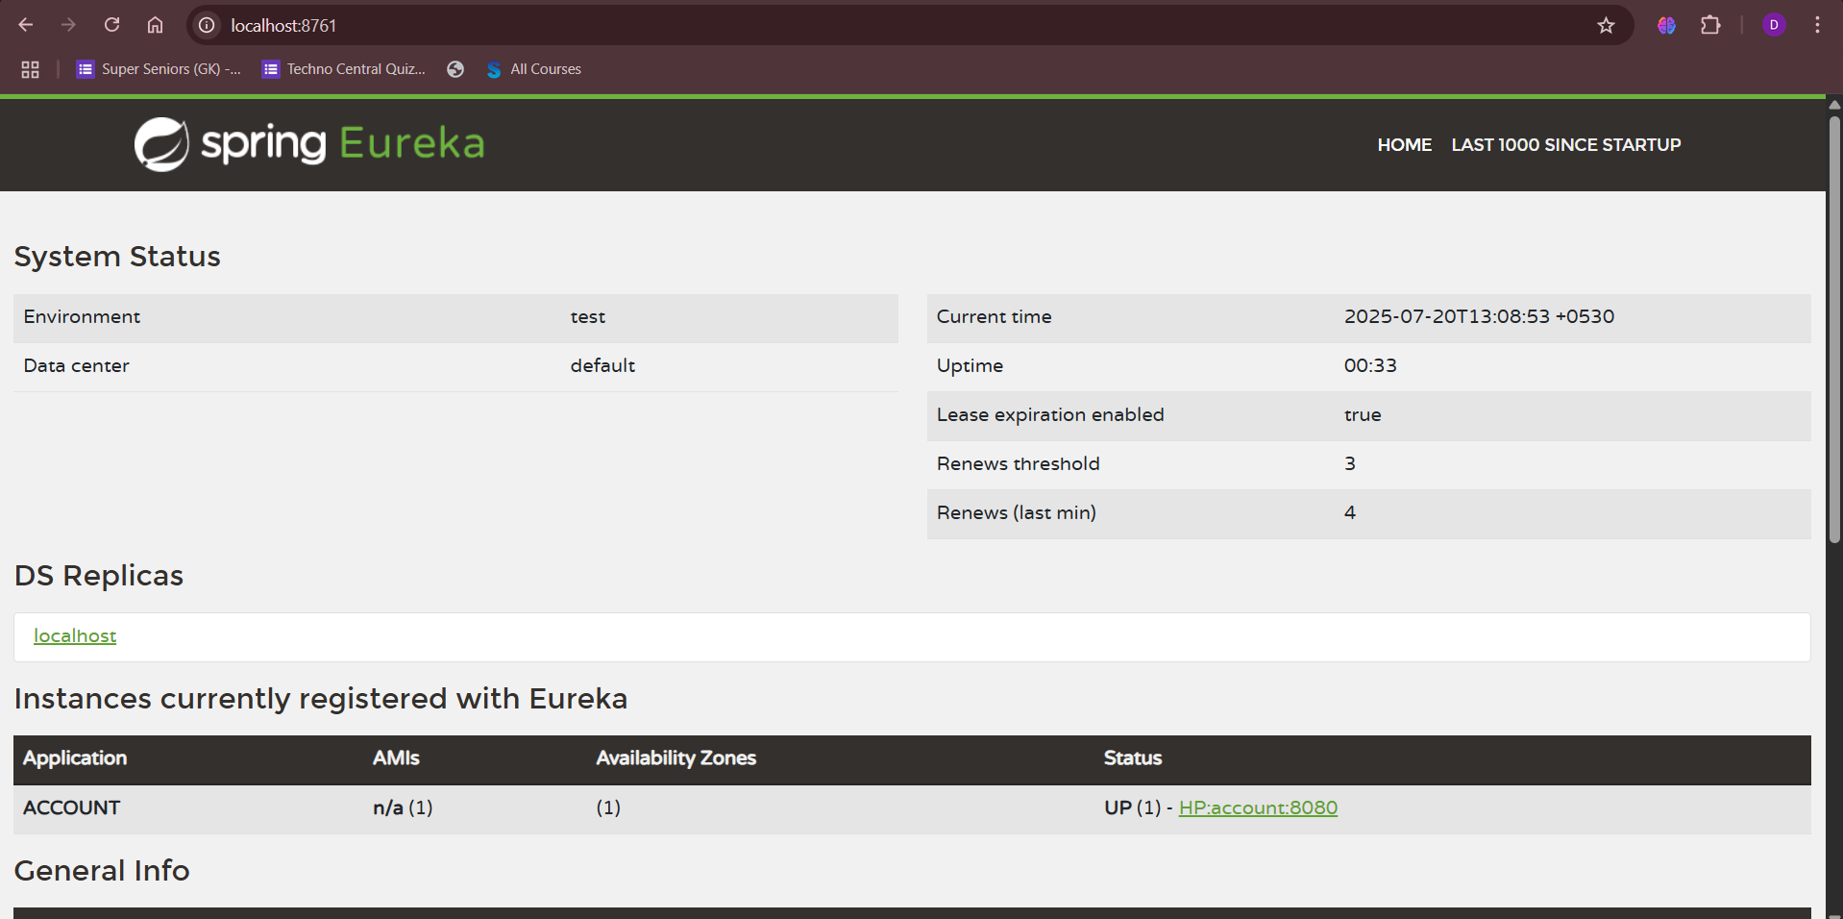

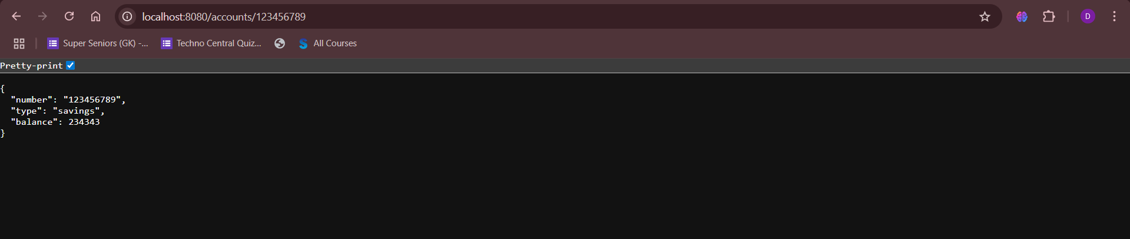

**Loan:**

